Python API
Source-Code editor: Visual Studio Code
Containerization platform: Docker
Code hosting & SDLC: GitHub
Cloud Hosting: Render
Database (Dev): SQLite
Database (Prod): PostgreSQL
Cloud Storage Platform: Cloudflare R2 bucket
Email delivery platform: Resend

  - Ahmed Karim – 15.10.2026

Table of Contents
Summary of Contents 4
Functionality 4
API Components 4
API URLs 7
Setup 8
Folders and Code 9
\Python_Code folder 9
Readme.txt 9
\Python_Code\prod_api folder 13
run_api.bat 13
.env 13
Requirements.txt 14
\Python_Code\prod_api\app folder 14
__init__.py 14
config.py 15
crud.py 16
database.py 18
logging_config.py 19
main.py 20
models.py 29
schemas.py 30
security.py 31
SMTP.py 32
\Python_Code\prod_api\app\routers folder 33
auth_routes.py 33
profile.py 41
users.py 47
\Python_Code\prod_api\app\templates folder 51
admin_users.html 51
dashboard.html 57
login.html 58
login_success.html 59
password_change.html 59
password_reset.html 61
password_reset_confirm.html 64
profile.html 68
\Python_Code\prod_api\app\templates\partials folder 72
user_row.html 72
\Python_Code\prod_api\data folder 74
\Python_Code\prod_api\static folder 74
\Python_Code\prod_api\static\uploads folder 74
Test all your code locally 75
Create your first admin user manually 75
Start your API locally 76
Fully test your API locally 76
Create Docker Container 78
Create a Dockerfile for your local Python FastAPI project 78
Paste this content into the Dockerfile 78
Quick test locally (optional but recommended) 79
Install Docker Desktop 79
Build the Docker image 81
Run your API from the Docker Image to make sure it is functioning properly 81
Create GitHub Repository 82
Install Git on your PC (if you don’t have it already) 82
Push your project to the new GitHub repository 82
Connect your local folder to the GitHub repository you just created 83
Create a Personal Access Token (needed to push the code) 84
Make sure GitHub’s Push Protection does not block your code push 86
Push the Code 87
Quick checklist after the push 87
Create and deploy the API’s Web Service on Render 89
Step-by-step deployment 89
Render will then do the following automatically: 90
FRONTEND_URL 91
Deployment Notes: 91
Thoroughly test your Render API with the SQLite database 91
Create and deploy a PostgreSQL database for production 92
Create a Render Postgres database 92
Get the connection string (‘DATABASE_URL’) 93
Add the connection string to your web service 93
Quick tips 93
Create your first admin user manually 94
Install PostgreSQL client (psql) 94
Using psql, check that the users table has been created properly in your new PostgreSQL database 94
Generate a correct password hash for your first admin user 95
Insert your first admin user 96
Create additional users 97
Thoroughly test your Render API with your new PostgreSQL database 97

Summary of Contents

Functionality
This document provides all the information need to implement a Python API (using FastAPI) securely available on the Internet, with the following functionality:
- User endpoints
  - Create, list, delete
  - Login Page
  - User Dashboard Page
  - Profile page, including photo upload
  - Change Password
  - Password Reset, including email sent to a real email address of a user
- RBAC
  - Standard vs. Admin users
  - Admin page to manage users
- Security
  - Hashed passwords
  - Encrypted session cookies
  - JWT stored inside cookies
  - CSRF protection
  - A full authentication middleware
- Validation
- Database (PostgreSQL + SQLAlchemy)
- Modular project structure
- Auto-generated documentation

API Components
The API will be built using the following components:

Component / Tool | Description
Python and HTML | - Program code of the API
Visual Studio Code | - Visual Studio Code (VS Code) is a lightweight yet powerful source-code editor which you will use to write and maintain your Python and HTML code
Docker | - Containerization platform to package the API code (developed locally on your computer) together with everything it needs (runtime, libraries, system tools) into a single, portable unit called a container  - The container is available on the Internet, so you can use it with other web-based platforms such as GitHub
GitHub | - GitHub is a cloud platform for hosting code and managing the entire software development lifecycle, built on top of the Git version-control system  - GitHub will use your Docker container  - You will continue to maintain and modify your API code locally with Visual Studio Code. When you are ready to publish your updates, you synchronize GitHub with your code updates
Render | - Render is a cloud hosting platform that lets you deploy and run applications, APIs, databases, static sites, background workers, and containers on the web without managing servers  - Instead of configuring infrastructure manually, you connect your GitHub repository, and Render builds, deploys, and hosts your app automatically
SQLite | - For simplicity, you can build and test your API code locally on your PC using a local SQLite database
PostgreSQL | - This is the database of your production API which will be created and hosted on Render  - SQLite will work with your production API and works fine for local development, prototypes, or very low-traffic single-process apps, but it has serious limitations in a production cloud environment like Render:  - Ephemeral filesystem by default:  - Render containers have an ephemeral filesystem; any files written after the container starts — including your SQLite .db file — are lost on every redeploy, restart, or (on free plans) spin-down after idle  - Concurrency & scaling limitations:  - SQLite uses a single-writer lock. Concurrent writes from multiple requests, multiple instances of your API, or background workers will queue or fail  - PostgreSQL uses proper multi-version concurrency control (MVCC) and handles many simultaneous connections without blocking  - No horizontal scaling  - You cannot easily run multiple instances of your web service sharing the same SQLite file. With PostgreSQL you can scale the web service freely; the database stays separate and shared  - Reliability, backups & operations - Render’s managed PostgreSQL gives you:  - Automatic daily backups + point-in-time recovery (on paid plans)  - Encryption at rest  - Easy connection string injection via environment variables  - High availability / read replicas on higher plans  - Automatic storage scaling  - No need to manage the database process yoursel  Managed Postgres is the standard recommendation on Render (and most PaaS platforms) precisely because it separates compute from durable state, removes single points of failure related to the filesystem, and is designed for concurrent web traffic.  IMPORTANT NOTE however: A free PostgreSQL database on Render will self-delete after 1 month:  - For a hobby/demo project with almost no concurrent writes and a persistent disk attached, SQLite will work fine  - For a real production API (real users, data durability, ability to scale, reliable backups): switch to a Render PostgreSQL database, and be prepared to pay the monthly subscription fee
Resend | - To enable sending password reset emails to the email addresses of users created in your Python API
Cloudflare R2 bucket | - Required free cloud storage where your API can upload static files, such as user profile pictures

API URLs
After the API is operational, the following functionality will be available on any device connected to the Internet – as long as an administrator of the API (you) has created a user id for you to authorize the person connecting to the API to log in.

The URLs below are for my published Python API on Render: https://prod-api-yrml.onrender.com/.

URL | Description
The following URLs do not require user credentials to access:
https://prod-api-yrml.onrender.com/docs | Interactive API documentation  (Swagger UI)
https://prod-api-yrml.onrender.com/redoc | FastAPI builds an OpenAPI JSON document describing all your endpoints, parameters, request bodies, and responses: ReDoc reads that document and displays it in a clean, structured, three-panel layout
https://prod-api-yrml.onrender.com/favicon.ico | Site favicon (a small icon that represents the website in your browser)
https://prod-api-yrml.onrender.com/login-page | Login page (HTML)
https://prod-api-yrml.onrender.com/api/password-reset | Request password reset
https://prod-api-yrml.onrender.com/health | Simple page showing the API’s health (system status)
The following URLs require an user id to authorize the person connecting to the API to log in (the user id needs to be created by an admin user of the API)
prod-api-yrml.onrender.com/dashboard | User dashboard page
prod-api-yrml.onrender.com/me | Current authenticated user info
https://prod-api-yrml.onrender.com/profile | User profile page/endpoint
https://prod-api-yrml.onrender.com/secret | Returns a simple message with the username and role (user or admin) of the authenticated user
https://prod-api-yrml.onrender.com/password-change | Change password page
https://prod-api-yrml.onrender.com/api/password-reset-confirm | Confirm password reset  (page is not directly accessible in the browser, except from a password reset link sent by email to a user of the API)
https://prod-api-yrml.onrender.com/logout | Log out the user
The following URLs require an admin of the API to be logged in
https://prod-api-yrml.onrender.com/admin/users | List all API users
https://prod-api-yrml.onrender.com/admin/users-page | Users management page for admins to use

Setup
1. On your Windows PC, create a Python_Code folder under C:\users\<your name\, i.e. a location where your standard Windows user id has full access without needing any administrative privileges.
Under the Python_Code folder, create the following subfolders:
- prod_api
Under the prod_api folder, create the following subfolders:
- app
- data
- static
Under the static folder, create the following subfolder:
- uploads
Under the app folder, create the following subfolder:
- routers
- templates
Under the templates folder, create the following subfolders:
- partials

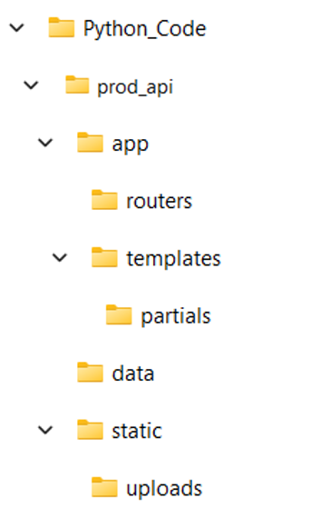

2. Before you begin, follow the instructions in \Python_Code\Readme.txt to install the prerequisites you need, before you can start coding in Python (see next chapter of this document).

Folders and Code

\Python_Code folder

Readme.txt

1. Install Python
https://www.python.org/downloads

2. Install Visual Studio Code for Python
https://code.visualstudio.com/

3. Install the SQLite command-line tool (optional but useful to manipulate data in the database used by your Python API)
i. Go to https://www.sqlite.org/download.html
ii. Download the Precompiled Binaries for Windows → sqlite-tools-win-x64-*.zip
iii. Unzip it somewhere (e.g. C:\sqlite)
iv. Add that folder to your system PATH

4. Create your Python Virtual Environment
i. Open CMD Terminal and go to your prod_api folder

ii. Run:
py -3.11 -m venv venv
venv\Scripts\activate
(replace 3.11 with whichever version of the Python interpreter you installed)

5. Using the pip install command, install all the following Python packages (they are used by some of the Python programs):
i. Make sure pip is up to date:
python.exe -m pip install --upgrade pip

ii Install following Python packages
python.exe -m pip install fastapi uvicorn jinja2 sqlalchemy passlib[argon2] python-jose python-multipart itsdangerous dotenv resend email-validator pydantic-settings boto3 ttkbootstrap pydantic[email] psycopg2-binary

6. Create a free account on https://resend.com (to enable sending password reset emails to the email addresses of users created in your Python API)
i. Go to https://resend.com → Sign up (you can use any email)
ii. Create an API key

7. Create a Cloudflare account (required to create storage for your Python API to upload files, e.g. user profile images)
i. Go to the official sign-up page: https://dash.cloudflare.com/sign-up, and sign-up to Cloudflare

ii. Enable Cloudflare R2 Object Storage (this is required free cloud storage where your API can upload static files, such as user profile pictures):
a. In the left sidebar, go to "Storage & databases → R2 → Overview" (direct link: https://dash.cloudflare.com/?to=/:account/r2/overview)
b. Click "Enable R2" / complete the checkout flow
Cloudflare requires a payment method, but you will not be charged if you stay before the free limit - currently 10 GB)

iii. Create your first bucket:
a. On the R2 Overview page, click "Create bucket"
b. Enter a bucket name (lowercase letters, numbers, and hyphens only — e.g. `my-app-uploads`)
c. Choose a location (or leave as "Automatic")
d. Click "Create bucket"

iv. Create API credentials (Access Key + Secret) - this is what your FastAPI app will use with "boto3":
a. On the R2 Overview page, look under "Account Details" and click "Manage" next to "API Tokens".
b. Click "Create Account API token"
c. Give it a name (e.g. "prod-api-r2")
d. Under "Permissions", choose:
- "Object Read & Write" (for your Python Api to upload and serve files)
- Optionally scope it to only your specific bucket for better security
e. Click "Create API Token"

f. Immediately copy and note the following in a separate location (e.g. a .txt file on your computer):
- "Access Key ID"
- "Secret Access Key" (you will NOTE be able to see the secret again)
g. Also note your "Account ID" (visible on the R2 Overview page or in the endpoint URL)

v. Activate the "public base URL" of your R2 bucket which end-users will use to view their uploaded files (profile pictures, etc.) via your API's Frontend:
a. Go to your bucket in the Cloudflare dashboard
b. Open the **Settings** tab
c. Under "Public Development URL" (or "R2.dev subdomain" / "Public access"), click "Enable" / "Allow Access"
4. Confirm by typing "allow".
5. Cloudflare will show you a URL that looks like: https://pub-xxxxxxxxxxxxxxxxxxxxxxxxxxxxxxxx.r2.dev
6. Immediately copy and note the above URL in a separate location (e.g. a .txt file on your computer)

8. Create a Docker account: https://www.docker.com/

9. Create a GitHub account: https://github.com

10. Create a Render account: https://render.com
a. Click on "Start for Free"
b. You can use your GitHub account to sign up to Render (for faster setup)

\Python_Code\prod_api folder

run_api.bat
REM You can use this batch file to run your API locally with your local SQLite database to test and confirm your code is fully functional before moving to production in the web

REM This batch file will work only if you have created and activated the Python virtual environment in a Terminal window

uvicorn app.main:app --reload --host 127.0.0.1 --port 8000

.env
SECRET_KEY=<Your secret key – a long random string>
DATABASE_URL=sqlite:///./data/test.db
RESEND_API_KEY=<API Key of your resend.com account you created earlier>
FROM_EMAIL=onboarding@resend.dev
FRONTEND_URL=http://127.0.0.1:8000
ENVIRONMENT=development
VERSION=<the version of your API – up to you to decide how you manage versioning>

R2_ACCOUNT_ID=<Cloudflare R2 Account ID which you noted earlier>
R2_ACCESS_KEY_ID=<Cloudflare R2 Access Key ID which you noted earlier>
R2_SECRET_ACCESS_KEY=<Cloudflare R2 Secret Access Key which you noted earlier>
R2_BUCKET=<Name of Cloudflare R2 bucket which you noted earlier>
R2_ENDPOINT= https://<your Cloudflare R2 Account ID>.r2.cloudflarestorage.com
R2_PUBLIC_URL=<Public base URL of your Cloudflare R2 bucket which you noted earlier> # or your custom domain later

Requirements.txt
Render installs your Python API’s dependencies (libraries from the Python Package Index - PyPI) from the requirements.txt file.
fastapi
uvicorn[standard]
sqlalchemy
python-jose[cryptography]
passlib[argon2]
python-multipart
jinja2
itsdangerous
python-dotenv
resend
email-validator
pydantic-settings
boto3
ttkbootstrap
pydantic[email]

psycopg2-binary # only if you switch to PostgreSQL
# or asyncpg if you go fully async later

\Python_Code\prod_api\app folder

__init__.py
#Empty
Create this file, but leave the file empty for now

config.py
# config.py
from pathlib import Path
from pydantic_settings import BaseSettings, SettingsConfigDict

BASE_DIR = Path(__file__).resolve().parent.parent # project root

class Settings(BaseSettings):
SECRET_KEY: str
DATABASE_URL: str = "sqlite:///./data/test.db"
RESEND_API_KEY: str
FROM_EMAIL: str = "onboarding@resend.dev"
FRONTEND_URL: str = "http://127.0.0.1:8000"
ENVIRONMENT: str = "development"
ACCESS_TOKEN_EXPIRE_MINUTES: int = 60
ALGORITHM: str = "HS256"
VERSION: str

# Cloudflare R2
R2_ACCOUNT_ID: str
R2_ACCESS_KEY_ID: str
R2_SECRET_ACCESS_KEY: str
R2_BUCKET: str
R2_ENDPOINT: str
R2_PUBLIC_URL: str

model_config = SettingsConfigDict(
env_file=str(BASE_DIR / ".env"),
env_file_encoding="utf-8",
extra="ignore", # ignore any extra variables in .env
case_sensitive=False, # optional but recommended
)

settings = Settings()

crud.py
from sqlalchemy.orm import Session
from fastapi import HTTPException, status
from datetime import datetime, timedelta
import secrets
from . import models, schemas
from .models import User
from .security import hash_password, get_password_hash # or just hash_password

def get_user_by_email(db: Session, email: str):
return db.query(models.User).filter(models.User.email == email).first()

def get_user_by_username(db: Session, username: str):
return db.query(models.User).filter(models.User.username == username).first()

def create_user(db: Session, user):
if get_user_by_email(db, user.email):
raise HTTPException(status_code=400, detail="Email already registered")
if get_user_by_username(db, user.username):
raise HTTPException(status_code=400, detail="Username already taken")

db_user = User(
username=user.username,
email=user.email,
password=hash_password(user.password),
role=user.role
)
db.add(db_user)
db.commit()
db.refresh(db_user)
return db_user

def update_user(db: Session, user: models.User, user_update: schemas.UserUpdate):
if user_update.email:
existing = get_user_by_email(db, user_update.email)
if existing and existing.id != user.id:
raise HTTPException(status_code=400, detail="Email already in use")
user.email = user_update.email

if user_update.password:
user.password = hash_password(user_update.password) # fixed

db.commit()
db.refresh(user)
return user

def create_reset_token(db: Session, email: str):
user = get_user_by_email(db, email)
if not user:
return None

token = secrets.token_urlsafe(32)
user.reset_token = token
user.reset_token_expires = datetime.utcnow() + timedelta(hours=1)
db.commit()
return token

def reset_password(db: Session, token: str, new_password: str):
user = db.query(models.User).filter(
models.User.reset_token == token,
models.User.reset_token_expires > datetime.utcnow()
).first()

if not user:
raise HTTPException(status_code=400, detail="Invalid or expired token")

user.password = hash_password(new_password) # fixed
user.reset_token = None
user.reset_token_expires = None
db.commit()
return user

database.py
from sqlalchemy import create_engine
from sqlalchemy.orm import sessionmaker, declarative_base
from .config import settings

DATABASE_URL = settings.DATABASE_URL

engine = create_engine(
DATABASE_URL,
connect_args={"check_same_thread": False} if DATABASE_URL.startswith("sqlite") else {},
pool_pre_ping=True,
)

SessionLocal = sessionmaker(autocommit=False, autoflush=False, bind=engine)
Base = declarative_base()

def get_db():
db = SessionLocal()
try:
yield db
finally:
db.close()

logging_config.py
import logging
from logging.config import dictConfig

# Simple version
logging.basicConfig(
level=logging.INFO, # or DEBUG in development
format="%(asctime)s | %(levelname)-8s | %(name)s | %(message)s",
)

logger = logging.getLogger(__name__)

main.py
from fastapi import FastAPI, Request, Depends, Form, HTTPException
from fastapi.staticfiles import StaticFiles
from fastapi.responses import FileResponse, HTMLResponse, RedirectResponse
from fastapi.templating import Jinja2Templates
from sqlalchemy.orm import Session
from itsdangerous import URLSafeTimedSerializer
from jose import jwt
from .security import SECRET_KEY, ALGORITHM, ACCESS_TOKEN_EXPIRE_MINUTES
from .config import settings
import secrets
import os

from .database import Base, engine, get_db
from . import models
from .models import User

# Import routers
from .routers import profile, users, auth_routes
from .routers.auth_routes import get_current_user, verify_password, create_access_token, require_roles

# Create DB tables
models.Base.metadata.create_all(bind=engine)

# Create the FastAPI app FIRST
app = FastAPI(
title="My API Backend",
docs_url="/docs" if settings.ENVIRONMENT != "production" else None,
redoc_url=None if settings.ENVIRONMENT == "production" else "/redoc",
)

@app.get("/")
def root():
return {"status": "ok", "message": "API is running"}

#HealthCheck
@app.get("/health")
async def health():
# optional: quick DB ping with timeout
return {
"status": "ok",
"version": settings.VERSION
}

# NOW include the routers
app.include_router(profile.router)
app.include_router(users.router)
app.include_router(auth_routes.router, prefix="/api")

# Static files
app.mount("/static", StaticFiles(directory="static"), name="static")

@app.get("/favicon.ico")
async def favicon():
return FileResponse("static/Swiss_Flag.png")

# Protected endpoint
@app.get("/secret")
def secret_area(current_user: User = Depends(get_current_user)):
return {
"message": "Top secret",
"user": current_user.username,
"role": current_user.role
}

import os

BASE_DIR = os.path.dirname(os.path.abspath(__file__))
templates = Jinja2Templates(directory=os.path.join(BASE_DIR, "templates"))

@app.get("/login-page", response_class=HTMLResponse)
def login_page(request: Request):
return templates.TemplateResponse(
request=request,
name="login.html",
)

#Login Successful

@app.get("/login-success", response_class=HTMLResponse)
def login_success(request: Request, username: str):
return templates.TemplateResponse(
request=request, # ← required
name="login_success.html",
context={"username": username} # "request" no longer needed inside context
)

# This serializer encrypts + signs the cookie so nobody can tamper with it.

serializer = URLSafeTimedSerializer(SECRET_KEY)

@app.post("/login")
def login(
username: str = Form(...),
password: str = Form(...),
remember_me: str = Form(None),
db: Session = Depends(get_db)
):
user = db.query(User).filter(User.username == username).first()

if not user or not verify_password(password, user.password):
return {"error": "Invalid credentials"}

#Last Login
from datetime import datetime, timezone
user.last_login = datetime.now(timezone.utc)
db.commit()

#Remember Me

# Short session = 1 hour
short_expiry = 3600

# Long session = 30 days
long_expiry = 60 * 60 * 24 * 30

# Choose expiry based on checkbox
expiry = long_expiry if remember_me else short_expiry

# Create JWT with correct expiry
token = create_access_token({"sub": username}, expires_delta=expiry)

# Encrypt + sign the JWT
encrypted_token = serializer.dumps(token)

# Create CSRF token
csrf_token = secrets.token_hex(32)

response = RedirectResponse(url="/dashboard", status_code=302)

# Set encrypted cookie
# JWT is created normally
#JWT is encrypted + signed
# Cookie is HTTP only
# Cookie expires in 1 hour
# Browser cannot read or modify it

is_production = settings.ENVIRONMENT == "production"

response.set_cookie(
key="session_token",
value=encrypted_token,
httponly=False,
secure=is_production, # True only in production
samesite="lax",
max_age=expiry # 1 hour or 30 days
)

# Set CSRF cookie (NOT httponly)
# Why CSRF cookie must NOT be httponly:
# Because your HTML form must read it and send it back

response.set_cookie(
key="csrf_token",
value=csrf_token,
httponly=False, # must be readable by browser
secure=is_production, # True only in production
samesite="lax",
max_age=expiry
)

return response

# CSRF validation middleware
# What this middleware does
# - Every POST request must include a CSRF token
# - The token must match the cookie
# - If not → request is rejected with 403 Forbidden
# This is exactly how Django and Flask protect forms

@app.middleware("http")
async def csrf_protect(request: Request, call_next):
# Paths that do NOT need CSRF protection
excluded_paths = {
"/login",
"/logout",
# add other public POSTs here if needed
}

if request.method in ("POST", "PUT", "DELETE") and request.url.path not in excluded_paths:

content_type = request.headers.get("content-type", "")

# Skip CSRF check for JSON requests (Swagger, frontend fetch, etc.)
if "application/json" in content_type:
return await call_next(request)

csrf_cookie = request.cookies.get("csrf_token")
csrf_form = None

if content_type.startswith("application/x-www-form-urlencoded") or \
content_type.startswith("multipart/form-data"):

# ---- Cache the body so the route can still read it ----
body = await request.body()

async def receive():
return {"type": "http.request", "body": body, "more_body": False}

request._receive = receive
# -------------------------------------------------------

form = await request.form()
csrf_form = form.get("csrf_token")

# Re-cache again after request.form() also consumed it
async def receive():
return {"type": "http.request", "body": body, "more_body": False}

request._receive = receive

if not csrf_cookie or not csrf_form or csrf_cookie != csrf_form:
raise HTTPException(status_code=403, detail="CSRF token invalid or missing")

return await call_next(request)

#User Dashboard

#Dasboard with JWT and CSRF

# Protect the dashboard using the encrypted JWT cookie
@app.get("/dashboard", response_class=HTMLResponse)

# Protects the dashboard
def dashboard(
request: Request,
current_user: User = Depends(get_current_user) # any logged-in user
# current_user: User = Depends(require_roles(["admin", "user"])) # if you want to restrict
):
csrf_token = request.cookies.get("csrf_token")

return templates.TemplateResponse(
request=request,
name="dashboard.html",
context={
"request": request,
"username": current_user.username,
"role": current_user.role, # now available in template
"csrf_token": csrf_token,
}
)

#Logout with CSRF
@app.get("/logout")
@app.post("/logout")

def logout(request: Request):
response = RedirectResponse(url="/login-page", status_code=302)
response.delete_cookie("session_token")
response.delete_cookie("csrf_token")
return response

models.py
from sqlalchemy import Column, Integer, String, Boolean, DateTime
from sqlalchemy.sql import func
from .database import Base

class User(Base):
__tablename__ = "users"

id = Column(Integer, primary_key=True, index=True)
username = Column(String, unique=True, index=True)
email = Column(String, unique=True, index=True)
password = Column(String)
role = Column(String, default="user") # ← added (user / admin / moderator ...)

is_active = Column(Boolean, default=True)
profile_picture = Column(String, nullable=True) # path to image
reset_token = Column(String, nullable=True)
reset_token_expires = Column(DateTime, nullable=True)
created_at = Column(DateTime(timezone=True), server_default=func.now())
last_login = Column(DateTime(timezone=True), nullable=True)

schemas.py
from pydantic import BaseModel, EmailStr
from typing import Optional
from datetime import datetime

class UserCreate(BaseModel):
username: str
email: EmailStr
password: str
role: str = "user" # ← add this (default to a safe value)

class UserUpdate(BaseModel):
email: Optional[EmailStr] = None
password: Optional[str] = None

class UserOut(BaseModel):
id: int
username: str
email: str
role: str
is_active: bool
profile_picture: Optional[str] = None

class Config:
from_attributes = True

class PasswordResetRequest(BaseModel):
email: EmailStr

class PasswordResetConfirm(BaseModel):
token: str
new_password: str

security.py
import resend
from .config import settings

resend.api_key = settings.RESEND_API_KEY

FROM_EMAIL = settings.FROM_EMAIL
FRONTEND_URL = settings.FRONTEND_URL

def send_password_reset_email(to_email: str, reset_token: str) -> None:
reset_link = f"{FRONTEND_URL}/api/password-reset/confirm?token={reset_token}"

params = {
"from": FROM_EMAIL,
"to": [to_email],
"subject": "Password Reset Request",
"html": f"""
<p>Hello,</p>
<p>You requested a password reset. Click the button below:</p>
<p>
<a href="{reset_link}"
style="background:#4CAF50;color:white;padding:10px 20px;
text-decoration:none;border-radius:5px;">
Reset Password
</a>
</p>
<p>Or copy this link:<br>{reset_link}</p>
<p>If you did not request this, ignore this email.</p>
""",
"text": f"Reset your password: {reset_link}"
}

resend.Emails.send(params)

SMTP.py
import resend
from .config import settings

resend.api_key = settings.RESEND_API_KEY

FROM_EMAIL = settings.FROM_EMAIL
FRONTEND_URL = settings.FRONTEND_URL

def send_password_reset_email(to_email: str, reset_token: str) -> None:
reset_link = f"{FRONTEND_URL}/api/password-reset/confirm?token={reset_token}"

params = {
"from": FROM_EMAIL,
"to": [to_email],
"subject": "Password Reset Request",
"html": f"""
<p>Hello,</p>
<p>You requested a password reset. Click the button below:</p>
<p>
<a href="{reset_link}"
style="background:#4CAF50;color:white;padding:10px 20px;
text-decoration:none;border-radius:5px;">
Reset Password
</a>
</p>
<p>Or copy this link:<br>{reset_link}</p>
<p>If you did not request this, ignore this email.</p>
""",
"text": f"Reset your password: {reset_link}"
}

resend.Emails.send(params)

\Python_Code\prod_api\app\routers folder

auth_routes.py
from pathlib import Path
from fastapi import APIRouter, Depends, HTTPException, status, Request, Form
from fastapi.responses import RedirectResponse, HTMLResponse
from sqlalchemy.orm import Session
from datetime import datetime, timedelta
from jose import jwt, JWTError
from typing import List
from fastapi.templating import Jinja2Templates
from itsdangerous import URLSafeTimedSerializer, BadSignature, SignatureExpired

from ..database import get_db
from ..crud import create_reset_token, reset_password
from ..schemas import PasswordResetRequest, PasswordResetConfirm
from ..models import User
from ..config import settings
from ..SMTP import send_password_reset_email
from ..security import (
SECRET_KEY, ALGORITHM, ACCESS_TOKEN_EXPIRE_MINUTES,
hash_password, verify_password
)

# Frontend URL
import os
FRONTEND_URL = os.getenv("FRONTEND_URL", "http://127.0.0.1:8000") # set real URL in production

# ---------- Robust template setup (fixes the unhashable dict error) ----------
BASE_DIR = Path(__file__).resolve().parent.parent # project root
templates_dir = BASE_DIR / "templates"
templates = Jinja2Templates(directory=str(templates_dir))

# --------------------------------------------------------------------------

router = APIRouter()

# JWT creation
def create_access_token(data: dict, expires_delta: int = None):
to_encode = data.copy()
if expires_delta:
expire = datetime.utcnow() + timedelta(seconds=expires_delta)
else:
expire = datetime.utcnow() + timedelta(minutes=ACCESS_TOKEN_EXPIRE_MINUTES)

to_encode.update({"exp": expire})
return jwt.encode(to_encode, SECRET_KEY, algorithm=ALGORITHM)

# -------------------------------------------------
# Cookie-based authentication
# -------------------------------------------------
serializer = URLSafeTimedSerializer(SECRET_KEY)

def get_current_user(request: Request, db: Session = Depends(get_db)) -> User:
encrypted_token = request.cookies.get("session_token")
if not encrypted_token:
raise HTTPException(status_code=401, detail="Not authenticated")

try:
token = serializer.loads(encrypted_token, max_age=60 * 60 * 24 * 30)
payload = jwt.decode(token, SECRET_KEY, algorithms=[ALGORITHM])
username: str = payload.get("sub")
if username is None:
raise HTTPException(status_code=401, detail="Invalid token")
except (JWTError, BadSignature, SignatureExpired, Exception):
raise HTTPException(status_code=401, detail="Invalid or expired token")

user = db.query(User).filter(User.username == username).first()
if user is None:
raise HTTPException(status_code=401, detail="User not found")

return user

# -------------------------------------------------
# RBAC helper
# -------------------------------------------------
def require_roles(allowed_roles: List[str]):
def role_checker(current_user: User = Depends(get_current_user)):
if current_user.role not in allowed_roles:
raise HTTPException(
status_code=status.HTTP_403_FORBIDDEN,
detail=f"Access denied. Required role(s): {', '.join(allowed_roles)}"
)
return current_user
return role_checker

# -------------------------------------------------
# Password Reset Endpoints
# -------------------------------------------------

import secrets
from fastapi.responses import HTMLResponse

@router.get("/password-reset", response_class=HTMLResponse)
def password_reset_page(request: Request):
csrf_token = secrets.token_hex(32)

response = templates.TemplateResponse(
request=request, # ← required keyword
name="password_reset.html",
context={
"csrf_token": csrf_token,
}
)

is_production = settings.ENVIRONMENT == "production"

response.set_cookie(
key="csrf_token",
value=csrf_token,
httponly=False,
secure=is_production, #True only in production
samesite="lax",
max_age=3600
)
return response

@router.post("/password-reset")
def request_password_reset(
request: Request,
email: str = Form(...),
db: Session = Depends(get_db)
):
token = create_reset_token(db, email)

if token:

# The email function already builds the correct link using settings.FRONTEND_URL
# reset_link = f"{FRONTEND_URL}/api/password-reset/confirm?token={token}"

# Keep the debug print if you still want it in development
# print("=== PASSWORD RESET LINK ===")
# print(reset_link)
# print("===========================")

# Actually send the email
try:
send_password_reset_email(email, token)
# return success response to the client
except Exception as e:
# log the error, return 500 or appropriate error
raise

# Re-render the same page with a success message (better than JSON)
return templates.TemplateResponse(
request=request,
name="password_reset.html",
context={
"message": "If the email exists, a reset link has been sent.",
"message_type": "success",
"email": email,
"csrf_token": request.cookies.get("csrf_token"),
}
)

@router.get("/password-reset/confirm", response_class=HTMLResponse)
def password_reset_confirm_page(request: Request, token: str):
import secrets
csrf_token = secrets.token_hex(32)

response = templates.TemplateResponse(
request=request,
name="password_reset_confirm.html",
context={
"token": token,
"csrf_token": csrf_token,
}
)

is_production = settings.ENVIRONMENT == "production"

response.set_cookie(
key="csrf_token",
value=csrf_token,
httponly=False,
secure=is_production, #True only in production
samesite="lax",
max_age=3600
)

return response

@router.post("/password-reset/confirm")
def password_reset_confirm(
request: Request,
token: str = Form(...),
new_password: str = Form(...),
confirm_password: str = Form(...), # ← required
db: Session = Depends(get_db)
):
# 1. Passwords must match
if new_password != confirm_password:
return templates.TemplateResponse(
request=request,
name="password_reset_confirm.html",
context={
"token": token,
"csrf_token": request.cookies.get("csrf_token"),
"messages": [{"tags": "danger", "message": "Passwords do not match"}],
},
status_code=400
)

# 2. Optional but recommended minimum length
if len(new_password) < 8:
return templates.TemplateResponse(
request=request,
name="password_reset_confirm.html",
context={
"token": token,
"csrf_token": request.cookies.get("csrf_token"),
"messages": [{"tags": "danger", "message": "Password must be at least 8 characters"}],
},
status_code=400
)

# 3. Everything OK → reset the password
reset_password(db, token, new_password)
return RedirectResponse(url="/login-page", status_code=302)

profile.py
from fastapi import APIRouter, Depends, Request, Form, UploadFile, File, HTTPException, status
from fastapi.responses import RedirectResponse, HTMLResponse
from sqlalchemy.orm import Session
from ..database import get_db
from ..models import User
from ..config import settings
from ..schemas import UserUpdate
from ..crud import update_user
from .auth_routes import get_current_user
from ..security import verify_password, hash_password
import uuid
import boto3
from botocore.client import Config
from fastapi.templating import Jinja2Templates
from pathlib import Path

router = APIRouter(tags=["Profile"])

templates = Jinja2Templates(
directory=str(Path(__file__).resolve().parent.parent / "templates")
)

# ---------- R2 helper ----------
def get_r2_client():
return boto3.client(
"s3",
endpoint_url=settings.R2_ENDPOINT,
aws_access_key_id=settings.R2_ACCESS_KEY_ID,
aws_secret_access_key=settings.R2_SECRET_ACCESS_KEY,
config=Config(signature_version="s3v4"),
region_name="auto", # R2 requires "auto"
)

def upload_to_r2(file: UploadFile, object_key: str) -> str:
"""Upload a file to R2 and return the public URL."""
client = get_r2_client()

# Read the file content
content = file.file.read() # or await file.read() if you prefer

client.put_object(
Bucket=settings.R2_BUCKET,
Key=object_key,
Body=content,
ContentType=file.content_type or "application/octet-stream",
# ACL is not needed for R2 public buckets / custom domains
)

# Return the public URL
return f"{settings.R2_PUBLIC_URL.rstrip('/')}/{object_key}"

# ---------- Profile routes ----------

@router.get("/profile", response_class=HTMLResponse)
def profile_page(request: Request, current_user: User = Depends(get_current_user)):
csrf_token = request.cookies.get("csrf_token")

if csrf_token is None:
import secrets
csrf_token = secrets.token_hex(32)

response = templates.TemplateResponse(
request,
"profile.html",
{
"user": current_user,
"csrf_token": csrf_token
}
)

is_production = settings.ENVIRONMENT == "production"

if request.cookies.get("csrf_token") is None:
response.set_cookie(
key="csrf_token",
value=csrf_token,
httponly=False,
secure=is_production,
samesite="lax",
max_age=3600
)

return response

@router.post("/profile")
async def update_profile(
request: Request,
email: str = Form(None),
password: str = Form(None),
profile_picture: UploadFile = File(None),
csrf_token: str = Form(...),
db: Session = Depends(get_db),
current_user: User = Depends(get_current_user)
):
update_data = UserUpdate(email=email, password=password if password else None)

# ---------- Handle profile picture (now to R2) ----------
if profile_picture and profile_picture.filename:
ext = profile_picture.filename.split(".")[-1].lower()
# Optional: validate allowed extensions
allowed = {"jpg", "jpeg", "png", "webp", "gif"}
if ext not in allowed:
raise HTTPException(status_code=400, detail="Invalid image type")

object_key = f"profile_pictures/{current_user.id}_{uuid.uuid4().hex}.{ext}"

# Upload to R2 and get the public URL
public_url = upload_to_r2(profile_picture, object_key)

# Store the full public URL in the database
current_user.profile_picture = public_url

update_user(db, current_user, update_data)
return RedirectResponse(url="/profile", status_code=302)

# ---------- Password Change ----------

@router.get("/password-change")
def password_change_page(
request: Request,
current_user: User = Depends(get_current_user)
):
return templates.TemplateResponse(
request, # ← Request first
"password_change.html",
{
"user": current_user,
"csrf_token": request.cookies.get("csrf_token"),
"messages": []
}
)

@router.post("/password-change")
async def password_change(
request: Request,
current_password: str = Form(...),
new_password: str = Form(...),
confirm_password: str = Form(...),
db: Session = Depends(get_db),
current_user: User = Depends(get_current_user)
):
# 1. Check that the two new passwords match
if new_password != confirm_password:
return templates.TemplateResponse(
request, # ← Request first
"password_change.html",
{
"user": current_user,
"csrf_token": request.cookies.get("csrf_token"),
"messages": [{"tags": "danger", "message": "New passwords do not match"}]
},
status_code=400
)

# 2. Verify the current password
if not verify_password(current_password, current_user.password):
return templates.TemplateResponse(
request, # ← Request first
"password_change.html",
{
"user": current_user,
"csrf_token": request.cookies.get("csrf_token"),
"messages": [{"tags": "danger", "message": "Current password is incorrect"}]
},
status_code=400
)

# 3. Update the password
update_data = UserUpdate(password=new_password)
update_user(db, current_user, update_data)

return RedirectResponse(url="/profile", status_code=status.HTTP_303_SEE_OTHER)

users.py
from fastapi import APIRouter, Depends, Request, HTTPException
from fastapi.responses import HTMLResponse, RedirectResponse
from fastapi.templating import Jinja2Templates
from sqlalchemy.orm import Session
from ..database import get_db
from ..schemas import UserCreate, UserOut
from ..crud import create_user
from app.routers.auth_routes import get_current_user, require_roles
from app.models import User
import os

router = APIRouter()

BASE_DIR = os.path.dirname(os.path.dirname(os.path.abspath(__file__)))
templates = Jinja2Templates(directory=os.path.join(BASE_DIR, "templates"))

@router.post("/users")
def create_new_user(
user: UserCreate,
db: Session = Depends(get_db),
current_user: User = Depends(require_roles(["admin"])),
):
return create_user(db, user)

@router.get("/me")
def read_me(current_user: User = Depends(get_current_user)):
return {
"username": current_user.username,
"email": current_user.email,
"role": current_user.role
}

@router.get("/admin/users", response_model=list[UserOut])
def list_all_users(
current_user: User = Depends(require_roles(["admin"])),
db: Session = Depends(get_db)
):
return db.query(User).all()

@router.get("/admin/users-page", response_class=HTMLResponse)
def admin_users_page(
request: Request,
current_user: User = Depends(require_roles(["admin"])),
db: Session = Depends(get_db)
):
users = db.query(User).all()
return templates.TemplateResponse(request, "admin_users.html", {
"request": request,
"users": users,
"current_user": current_user,
"csrf_token": request.cookies.get("csrf_token")
})

@router.post("/admin/users/{user_id}/toggle", response_class=HTMLResponse)
def toggle_user_active(
request: Request,
user_id: int,
db: Session = Depends(get_db),
current_user: User = Depends(require_roles(["admin"]))
):
user = db.query(User).filter(User.id == user_id).first()
if not user:
raise HTTPException(status_code=404, detail="User not found")
if user.id == current_user.id:
raise HTTPException(status_code=400, detail="You cannot deactivate yourself")

user.is_active = not user.is_active
db.commit()
db.refresh(user)

return templates.TemplateResponse(
request,
"partials/user_row.html",
{
"request": request,
"user": user,
"current_user": current_user,
"csrf_token": request.cookies.get("csrf_token"),
}
)

@router.delete("/admin/users/{user_id}", response_class=HTMLResponse)
def delete_user(
user_id: int,
db: Session = Depends(get_db),
current_user: User = Depends(require_roles(["admin"]))
):
user = db.query(User).filter(User.id == user_id).first()
if not user:
raise HTTPException(status_code=404, detail="User not found")
if user.id == current_user.id:
raise HTTPException(status_code=400, detail="You cannot delete yourself")

db.delete(user)
db.commit()

# Return empty response → HTMX removes the row
return HTMLResponse(content="")

\Python_Code\prod_api\app\templates folder

admin_users.html
<!DOCTYPE html>
<html lang="en">
<head>
<meta charset="UTF-8">
<meta name="viewport" content="width=device-width, initial-scale=1.0">
<title>Admin – Users</title>
<script src="https://unpkg.com/htmx.org@1.9.12"></script>
<style>
:root {
--bg: #0f172a;
--card: #1e293b;
--border: #334155;
--text: #e2e8f0;
--muted: #94a3b8;
--accent: #3b82f6;
--danger: #ef4444;
--success: #22c55e;
}
* { box-sizing: border-box; margin: 0; padding: 0; }
body {
font-family: system-ui, -apple-system, sans-serif;
background: var(--bg);
color: var(--text);
line-height: 1.5;
min-height: 100vh;
}
.container {
max-width: 1100px;
margin: 0 auto;
padding: 2rem 1.5rem;
}
header {
display: flex;
justify-content: space-between;
align-items: center;
margin-bottom: 2rem;
flex-wrap: wrap;
gap: 1rem;
}
h1 { font-size: 1.75rem; font-weight: 700; }
.nav a {
color: var(--muted);
text-decoration: none;
margin-left: 1.25rem;
font-size: 0.95rem;
}
.nav a:hover { color: var(--accent); }
.card {
background: var(--card);
border: 1px solid var(--border);
border-radius: 12px;
overflow: hidden;
}
table {
width: 100%;
border-collapse: collapse;
}
th, td {
padding: 0.9rem 1.1rem;
text-align: left;
border-bottom: 1px solid var(--border);
}
th {
background: #0f172a;
font-size: 0.8rem;
text-transform: uppercase;
letter-spacing: 0.05em;
color: var(--muted);
}
tr:last-child td { border-bottom: none; }
tr:hover td { background: rgba(59, 130, 246, 0.05); }
.badge {
display: inline-block;
padding: 0.2rem 0.55rem;
border-radius: 999px;
font-size: 0.75rem;
font-weight: 600;
}
.badge-admin { background: #1e40af; color: #bfdbfe; }
.badge-user { background: #334155; color: #cbd5e1; }
.badge-active { background: #14532d; color: #86efac; }
.badge-inactive { background: #7f1d1d; color: #fca5a5; }
.avatar {
width: 36px;
height: 36px;
border-radius: 50%;
object-fit: cover;
background: #334155;
vertical-align: middle;
margin-right: 0.6rem;
}
.btn {
display: inline-block;
padding: 0.35rem 0.75rem;
border-radius: 6px;
font-size: 0.8rem;
font-weight: 500;
border: none;
cursor: pointer;
text-decoration: none;
transition: opacity 0.15s;
}
.btn:hover { opacity: 0.85; }
.btn-danger { background: var(--danger); color: white; }
.btn-outline {
background: transparent;
border: 1px solid var(--border);
color: var(--text);
}
.actions { display: flex; gap: 0.4rem; }
.empty {
padding: 3rem;
text-align: center;
color: var(--muted);
}
.htmx-indicator {
display: none;
margin-left: 0.5rem;
color: var(--muted);
font-size: 0.85rem;
}
.htmx-request .htmx-indicator { display: inline; }
</style>
</head>
<body>
<div class="container">
<header>
<h1>User Management</h1>
<nav class="nav">
<a href="/dashboard">Dashboard</a>
<a href="/profile">My Profile</a>
<a href="/admin/users-page">Users</a>
<form action="/logout" method="post" style="display:inline;">
<button type="submit" class="btn btn-outline" style="margin-left:1rem;">Logout</button>
</form>
</nav>
</header>

<div class="card">
{% if users %}
<table>
<thead>
<tr>
<th>User</th>
<th>Email</th>
<th>Role</th>
<th>Status</th>
<th>Joined</th>
<th>Actions</th>
</tr>
</thead>
<tbody>
{% for user in users %}
{% include "partials/user_row.html" %}
{% endfor %}
</tbody>
</table>
{% else %}
<div class="empty">No users found.</div>
{% endif %}
</div>
</div>
</body>
</html>

dashboard.html
<!DOCTYPE html>
<html>
<head>
<title>Dashboard</title>
</head>
<body>
<h2>Welcome to your Dashboard</h2>
<p>Hello, {{ username }}!</p>

<p>This is your private dashboard page.</p>

<form action="/logout" method="post">
<input type="hidden" name="csrf_token" value="{{ request.cookies.get('csrf_token') }}">
<button type="submit">Logout</button>
</form>
</body>
</html>

login.html
<!DOCTYPE html>
<html>
<head>
<title>Login</title>
</head>
<body>
<h2>Login</h2>
<form action="/login" method="post">
<label>Username:</label><br>
<input type="text" name="username"><br><br>

<label>Password:</label><br>
<input type="password" name="password"><br><br>

<button type="submit">Login</button>

<label>
<input type="checkbox" name="remember_me">
Remember me
</label>

<input type="hidden" name="csrf_token" value="{{ request.cookies.get('csrf_token') }}">
</form>
</body>
</html>

login_success.html
<!DOCTYPE html>
<html>
<head>
<title>Login Successful</title>
</head>
<body>
<h2>Login Successful</h2>
<p>Welcome, {{ username }}!</p>
</body>
</html>

password_change.html
<!DOCTYPE html>
<html lang="en">
<head>
<meta charset="UTF-8">
<meta name="viewport" content="width=device-width, initial-scale=1.0">
<title>Change Password</title>
<link href="https://cdn.jsdelivr.net/npm/bootstrap@5.3.3/dist/css/bootstrap.min.css" rel="stylesheet">
</head>
<body class="bg-light">
<div class="container py-5">
<div class="row justify-content-center">
<div class="col-md-6 col-lg-5">
<div class="card shadow-sm">
<div class="card-header bg-primary text-white">
<h4 class="mb-0">Change Password</h4>
</div>
<div class="card-body">

{% if messages %}
{% for message in messages %}
<div class="alert alert-{{ message.tags if message.tags else 'info' }} alert-dismissible fade show" role="alert">
{{ message.message if message.message else message }}
<button type="button" class="btn-close" data-bs-dismiss="alert"></button>
</div>
{% endfor %}
{% endif %}

<form method="post" action="/password-change">
<!-- CSRF token -->
<input type="hidden" name="csrf_token" value="{{ csrf_token or '' }}">

<div class="mb-3">
<label class="form-label">Current Password</label>
<input type="password" name="current_password" class="form-control" required>
</div>
<div class="mb-3">
<label class="form-label">New Password</label>
<input type="password" name="new_password" class="form-control" required minlength="8">
</div>
<div class="mb-3">
<label class="form-label">Confirm New Password</label>
<input type="password" name="confirm_password" class="form-control" required minlength="8">
</div>

<div class="d-grid gap-2">
<button type="submit" class="btn btn-primary">Update Password</button>
<a href="/profile" class="btn btn-outline-secondary">Cancel</a>
</div>
</form>
</div>
</div>
</div>
</div>
</div>
<script src="https://cdn.jsdelivr.net/npm/bootstrap@5.3.3/dist/js/bootstrap.bundle.min.js"></script>
</body>
</html>

password_reset.html
<!DOCTYPE html>
<html lang="en">
<head>
<meta charset="UTF-8">
<meta name="viewport" content="width=device-width, initial-scale=1.0">
<title>Password Reset</title>
<link href="https://cdn.jsdelivr.net/npm/bootstrap@5.3.3/dist/css/bootstrap.min.css" rel="stylesheet">
</head>
<body class="bg-light">
<div class="container py-5">
<div class="row justify-content-center">
<div class="col-md-6 col-lg-5">
<div class="card shadow-sm">
<div class="card-header bg-primary text-white text-center">
<h4 class="mb-0">Reset Your Password</h4>
</div>
<div class="card-body">
<p class="text-muted mb-4">
Enter your email address and we’ll send you a link to reset your password.
</p>

{# Optional success / error messages #}
{% if message %}
<div class="alert alert-{{ message_type|default('info') }} alert-dismissible fade show" role="alert">
{{ message }}
<button type="button" class="btn-close" data-bs-dismiss="alert"></button>
</div>
{% endif %}

{% if error %}
<div class="alert alert-danger alert-dismissible fade show" role="alert">
{{ error }}
<button type="button" class="btn-close" data-bs-dismiss="alert"></button>
</div>
{% endif %}

<form method="post" action="/api/password-reset">
<!-- CSRF protection -->
<input type="hidden" name="csrf_token" value="{{ csrf_token }}">

<div class="mb-3">
<label for="email" class="form-label">Email address</label>
<input type="email"
class="form-control"
id="email"
name="email"
required
placeholder="you@example.com"
value="{{ email|default('') }}">
</div>

<div class="d-grid">
<button type="submit" class="btn btn-primary">Send Reset Link</button>
</div>
</form>

<div class="mt-3 text-center">
<a href="/login-page" class="text-decoration-none">Back to Login</a>
</div>
</div>
</div>
</div>
</div>
</div>
<script src="https://cdn.jsdelivr.net/npm/bootstrap@5.3.3/dist/js/bootstrap.bundle.min.js"></script>
</body>
</html>

password_reset_confirm.html
<!DOCTYPE html>
<html lang="en">
<head>
<meta charset="UTF-8">
<meta name="viewport" content="width=device-width, initial-scale=1.0">
<title>Set New Password</title>
<link href="https://cdn.jsdelivr.net/npm/bootstrap@5.3.3/dist/css/bootstrap.min.css" rel="stylesheet">
</head>

<body class="bg-light">
<div class="container py-5">
<div class="row justify-content-center">
<div class="col-md-6 col-lg-5">
<div class="card shadow-sm">

<div class="card-header bg-primary text-white text-center">
<h4 class="mb-0">Set New Password</h4>
</div>

<div class="card-body">

{% if messages %}
{% for message in messages %}
<div class="alert alert-{{ message.tags }} alert-dismissible fade show" role="alert">
{{ message.message }}
<button type="button" class="btn-close" data-bs-dismiss="alert"></button>
</div>
{% endfor %}
{% endif %}

{% if token %}
<p class="text-muted mb-4">
Please enter your new password twice so we can verify it.
</p>

{% if error %}
<div class="alert alert-danger alert-dismissible fade show" role="alert">
{{ error }}
<button type="button" class="btn-close" data-bs-dismiss="alert"></button>
</div>
{% endif %}

{% if message %}
<div class="alert alert-success alert-dismissible fade show" role="alert">
{{ message }}
<button type="button" class="btn-close" data-bs-dismiss="alert"></button>
</div>
{% endif %}

<form method="post" action="/api/password-reset/confirm">

<!-- CSRF token -->
<input type="hidden" name="csrf_token" value="{{ csrf_token }}">

<!-- Reset token -->
<input type="hidden" name="token" value="{{ token }}">

<div class="mb-3">
<label for="new_password" class="form-label">New password</label>
<input type="password"
class="form-control"
id="new_password"
name="new_password"
required>
</div>

<div class="mb-3">
<label for="confirm_password" class="form-label">Confirm new password</label>
<input type="password"
class="form-control"
id="confirm_password"
name="confirm_password"
required>
</div>

<div class="d-grid">
<button type="submit" class="btn btn-primary">Change Password</button>
</div>
</form>

{% else %}
<div class="alert alert-danger">
The password reset link is invalid or expired.
Please request a new password reset.
</div>
{% endif %}

</div>
</div>
</div>
</div>
</div>

<script src="https://cdn.jsdelivr.net/npm/bootstrap@5.3.3/dist/js/bootstrap.bundle.min.js"></script>
</body>
</html>

profile.html
<!DOCTYPE html>
<html lang="en">
<head>
<meta charset="UTF-8">
<meta name="viewport" content="width=device-width, initial-scale=1.0">
<title>My Profile</title>
<link href="https://cdn.jsdelivr.net/npm/bootstrap@5.3.3/dist/css/bootstrap.min.css" rel="stylesheet">
</head>
<body class="bg-light">
<div class="container py-5">
<div class="row justify-content-center">
<div class="col-md-8 col-lg-6">
<div class="card shadow-sm">
<div class="card-header bg-primary text-white">
<h4 class="mb-0">My Profile</h4>
</div>
<div class="card-body">
{% if messages %}
{% for message in messages %}
<div class="alert alert-{{ message.tags }} alert-dismissible fade show" role="alert">
{{ message.message }}
<button type="button" class="btn-close" data-bs-dismiss="alert"></button>
</div>
{% endfor %}
{% endif %}

<form method="post" enctype="multipart/form-data">
<input type="hidden" name="csrf_token" value="{{ csrf_token }}">

<div class="mb-3">
<label for="email" class="form-label">Email</label>
<input type="email" class="form-control" id="email" name="email" value="{{ user.email }}">
</div>

<div class="mb-3">
<label for="password" class="form-label">New Password</label>
<input type="password" class="form-control" id="password" name="password">
</div>

<div class="mb-3">
<label for="profile_picture" class="form-label">Profile Picture</label>
<input type="file" class="form-control" id="profile_picture" name="profile_picture">
</div>

<div class="mb-4 text-center">
{% if user.profile_picture %}
<img src="{{ user.profile_picture }}"
alt="Profile picture"
class="rounded-circle mb-3"
style="width: 150px; height: 150px; object-fit: cover; border: 3px solid #0d6efd;">
{% else %}
<div class="rounded-circle bg-secondary d-inline-flex align-items-center justify-content-center mb-3"
style="width: 150px; height: 150px; color: white; font-size: 3rem;">
{{ user.username[0]|upper if user.username else '?' }}
</div>
{% endif %}
</div>

<div class="mb-4">
<h5 class="text-muted">Account Information</h5>
<hr>
<p><strong>Username:</strong> {{ user.username }}</p>
<p><strong>Email:</strong> {{ user.email|default('Not set') }}</p>
<p><strong>Date Joined:</strong>
{{ user.created_at.strftime('%B %d, %Y') if user.created_at else 'N/A' }}
</p>
<p><strong>Last Login:</strong>
{{ user.last_login.strftime('%B %d, %Y %H:%M') if user.last_login else 'Never' }}
</p>
</div>

<div class="d-grid">
<button type="submit" class="btn btn-primary">Update Profile</button>
</div>
</form>

<div class="d-grid gap-2">
<a href="/password-change" class="btn btn-outline-primary">Change Password</a>
<a href="/logout" class="btn btn-outline-danger">Logout</a>
</div>
</div>
</div>
</div>
</div>
</div>
<script src="https://cdn.jsdelivr.net/npm/bootstrap@5.3.3/dist/js/bootstrap.bundle.min.js"></script>
</body>
</html>

\Python_Code\prod_api\app\templates\partials folder

user_row.html
<tr id="user-row-{{ user.id }}">
<td>
{% if user.profile_picture %}
<img src="/uploads/{{ user.profile_picture }}" alt="" class="avatar">
{% else %}
<span class="avatar" style="display:inline-flex;align-items:center;justify-content:center;font-size:0.9rem;">
{{ user.username[0]|upper }}
</span>
{% endif %}
{{ user.username }}
</td>
<td>{{ user.email }}</td>
<td>
{% if user.is_admin %}
<span class="badge badge-admin">Admin</span>
{% else %}
<span class="badge badge-user">User</span>
{% endif %}
</td>
<td>
{% if user.is_active %}
<span class="badge badge-active">Active</span>
{% else %}
<span class="badge badge-inactive">Inactive</span>
{% endif %}
</td>
<td>{{ user.created_at.strftime('%Y-%m-%d') if user.created_at else '—' }}</td>
<td>
<div class="actions">
<!-- Toggle active status (HTMX) -->
<button
class="btn btn-outline"
hx-post="/admin/users/{{ user.id }}/toggle"
hx-target="#user-row-{{ user.id }}"
hx-swap="outerHTML"
hx-vals='{"csrf_token": "{{ csrf_token }}"}'
{% if user.id == current_user.id %}disabled title="You cannot deactivate yourself"{% endif %}>
{% if user.is_active %}Deactivate{% else %}Activate{% endif %}
</button>

<!-- Delete user (HTMX) -->
<button
class="btn btn-danger"
hx-delete="/admin/users/{{ user.id }}"
hx-target="#user-row-{{ user.id }}"
hx-swap="outerHTML"
hx-confirm="Are you sure you want to delete {{ user.username }}?"
hx-vals='{"csrf_token": "{{ csrf_token }}"}'
{% if user.id == current_user.id %}disabled title="You cannot delete yourself"{% endif %}>
Delete
</button>
</div>
</td>
</tr>

\Python_Code\prod_api\data folder
Leave this folder empty for now
A database will be created in this folder the first time you run your Python API

\Python_Code\prod_api\static folder
Add here a .png file of your choice which will be your API site’s favicon.

Then make a change to the following code in main.py:

@app.get("/favicon.ico")
async def favicon():
return FileResponse("static/Swiss_Flag.png")

Change Swiss_Flag.png above to the name of your favicon file

\Python_Code\prod_api\static\uploads folder

Leave this folder empty
Your code in profile.py is uploading user profile pictures to the Cloudflare R2 bucket, but this uploads folder can be used for local tests in case you are having issues with the uploads to Cloudflare R2.

Test all your code locally

Create your first admin user manually
- In the prod_api folder, create a new Python file: create_admin.py for one-time use with the following code:

from app.database import SessionLocal, engine
from app.models import Base, User

# Import routers
from app.routers import profile, users, auth_routes
from app.routers.auth_routes import get_current_user, verify_password, create_access_token, require_roles

from app.security import (
SECRET_KEY, ALGORITHM, ACCESS_TOKEN_EXPIRE_MINUTES,
hash_password, verify_password
)

from datetime import datetime, timezone

# Recreate tables (just in case)
Base.metadata.create_all(bind=engine)

db = SessionLocal()

# Check if admin already exists
existing = db.query(User).filter(User.username == "a-<your name>").first()
if existing:
print("Admin user already exists!")
else:
admin = User(
username="a-<your name>",
email="<your email address>,
password=hash_password("<your strong password>"),
role="admin",
is_active=True,
created_at=datetime.now(timezone.utc),
)
db.add(admin)
db.commit()
print("Admin user created successfully!")

db.close()

- In a CMD (terminal) window, go to the prod_api folder and activate your Python virtual environment as described in the section Readme.txt

- Run create_admin.py
Python create_admin.py

Start your API locally
- In the CMD window with the active Python virtual environment, start your API - Run:
run_api.bat

- Open a web browser, go to http://127.0.0.1:8000/login-page
  - Then login with your newly created admin user

- After being authenticated, open another tab on the web browser and go to http://127.0.0.1:8000/docs
  - Using 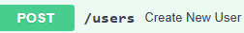, create one or more new standard users

Fully test your API locally
i. Test your locally running API URLs and confirm that the related functionalities are fully working:
URL | Description
The following URLs do not require user credentials to access:
http://127.0.0.1:8000/docs | Interactive API documentation  (Swagger UI)
http://127.0.0.1:8000/redoc | FastAPI builds an OpenAPI JSON document describing all your endpoints, parameters, request bodies, and responses: ReDoc reads that document and displays it in a clean, structured, three-panel layout
http://127.0.0.1:8000/favicon.ico | Site favicon (a small icon that represents the website in your browser)
http://127.0.0.1:8000/login-page | Login page (HTML)
http://127.0.0.1:8000/api/password-reset | Request password reset
http://127.0.0.1:8000/health | Simple page showing the API’s health (system status)
The following URLs require an user id to authorize the person connecting to the API to log in (the user id needs to be created by an admin user of the API)
http://127.0.0.1:8000/dashboard | User dashboard page
http://127.0.0.1:8000/me | Current authenticated user info
http://127.0.0.1:8000/profile | User profile page/endpoint
http://127.0.0.1:8000/secret | Returns a simple message with the username and role (user or admin) of the authenticated user
http://127.0.0.1:8000/password-change | Change password page
http://127.0.0.1:8000/api/password-reset-confirm | Confirm password reset  (page is not directly accessible in the browser, except from a password reset link sent by email to a user of the API)
http://127.0.0.1:8000/logout | Log out the user
The following URLs require an admin of the API to be logged in
http://127.0.0.1:8000/admin/users | List all API users
http://127.0.0.1:8000/admin/users-page | Users management page for admins to use

ii. Also test other functionality in http://127.0.0.1:8000/docs which cannot be directly access via a URL on a page on your Web browser.

Create Docker Container
Render can run FastAPI without Docker, but Docker is more stable, especially with static files and templates.

Create a Dockerfile for your local Python FastAPI project
- Open your prod_api folder in File Explorer.
- Right-click → New → Text Document.
- Name it Dockerfile (delete the .txt extension completely).
Windows may warn you — click Yes.
- Open it with Visual Studio Code

Paste this content into the Dockerfile
(replace 3.11 with whichever version of the Python interpreter you installed)

# Use a maintained Python 3.11 image
FROM python:3.11-slim

# Set working directory
WORKDIR /app

# Environment variables
ENV PYTHONDONTWRITEBYTECODE=1
ENV PYTHONUNBUFFERED=1

# Install system dependencies (only if needed)
RUN apt-get update && apt-get install -y --no-install-recommends \
build-essential \
&& rm -rf /var/lib/apt/lists/*

# Copy requirements first (better caching)
COPY requirements.txt .

# Install Python packages
RUN pip install --no-cache-dir -r requirements.txt

# Copy the rest of the code
COPY . .

# Expose port
EXPOSE 8000

# Start the app
CMD ["uvicorn", "app.main:app", "--host", "0.0.0.0", "--port", "8000"]

Quick test locally (optional but recommended)

Install Docker Desktop

1. Check system requirements
Docker Desktop needs virtualization support enabled on your machine.
- Ensure Windows 10 or 11 is installed
- On Windows: verify WSL2 is installed

2. Download Docker Desktop
Go to: https://www.docker.com/products/docker-desktop/
- Choose Download Docker Desktop / Windows AMD64
- Save the installer file

3. Run the installer
This installs Docker Engine, Docker CLI, and Docker Desktop UI.
- Double-click the installer
- Accept the license agreement
- On Windows: ensure WSL2 option is checked
- Complete installation and reboot your PC if prompted

4. Launch Docker Desktop
Docker Desktop manages containers and images visually.
- Open Docker Desktop from your applications menu
- Wait until it shows Docker is running
- If prompted, allow privileged access

5. Verify Docker installation
Most Common Check: Confirm Docker Engine is working correctly:
Open a CMD (Terminal) window and run:
docker --version
(You should see a version like Docker version 27.x.x

docker run hello-world
(this confirms proper container execution)
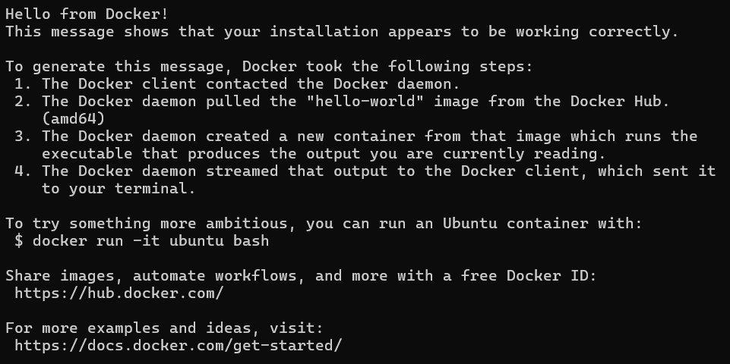
You have now installed:
- Docker Engine: Runs containers
- Docker CLI: Command-line control
- Docker Desktop: GUI for images, containers, volumes, logs
- WSL2 backend (Windows): fast Linux-based containers

This setup is perfect for FastAPI development, especially when you start containerizing your API or running Postgres/Redis locally.

Build the Docker image
Before proceeding, make sure that you have started Docker Desktop and that the Docker Engine is running, as detailed in the previous section.

1. Open a CMD (Terminal) Window
2. Go to the prod_api folder
3. Run:
docker build -t my-fastapi-app .
(The . at the end means “use the current folder as the build context”.)
- Docker will now automatically create the Container and display progress in the CMD window (this will take some time)
  - Monitor the progress carefully, and check for any unexpected errors during container creation (if there are any errors, there is a problem somewhere in your code which you will need to debug and fix)

Run your API from the Docker Image to make sure it is functioning properly
1. In a CMD (Terminal) Window, start your Python API from the Docker Image:
docker run -p 8000:8000 my-fastapi-app

You should see:
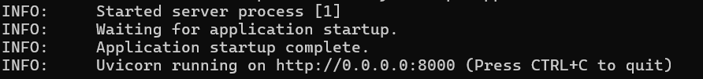
2. Then open http://localhost:8000/login-page in your browser.
3. Test thoroughly your API running from the Docker container as you did in section Fully test your API locally
- Use http://localhost:8000/ as the prefix of the URLs for your API pages within the Docker container, instead of the local http://127.0.0.1:8000/
For example, http://localhost:8000/docs, instead of http://127.0.0.1:8000/docs

Once the Dockerfile is saved in the project root, you can commit and push it to GitHub together with the rest of your code.

Create GitHub Repository
After you have confirmed that your Docker Container is fully working, proceed to creating your GitHub repository.

Install Git on your PC (if you don’t have it already)
1. Windows: Download and install from https://git-scm.com/download/win. Use the default options.

2. After installation, open a CMD (Terminal) window and verify:
git --version

You should see something like:

Push your project to the new GitHub repository
- Open a CMD (Terminal) window
- Go into your project folder prod_api:
cd <path to>\prod_api

(Replace <path to> with the real location of prod_api on your computer)
- Initialize a Git repository:
git init

- Add all files:
git add .

- Make the first commit:
git commit -m "Initial commit - FastAPI project"

- Rename the default branch to main (modern standard):
git branch -M main

Connect your local folder to the GitHub repository you just created
1. Open your browser and go to https://github.com

2. Make sure you are logged in with your email address
(as you specified when you registered to GitHub in the section Readme.txt)

3. On the left pane, under click on the empty repository you just created
- The URL in the browser address bar will look like:
https://github.com/YOUR-ACTUAL-USERNAME/prod_api

4. Open Git GUI
(either launch it from the Start menu / applications and choose “Open Existing Repository”, or right-click the folder → “Git GUI Here”).

5. Click Open Existing Repository

6. In the dialog box that follows, browse to your prod_api folder and select and open this folder.
7. From the menu bar, select Remote/Add:
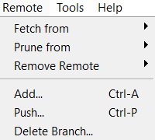
8. Fill in the dialog box that opens, then click Add
- Name: origin
- Location: <URL you noted on step 3. above>.git

(in the format https://github.com/YOUR-ACTUAL-USERNAME/prod_api>.git)

- Further Action: Fetch Immediately
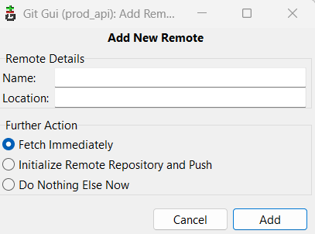

Note: You can active the same from a CMD (Terminal) window with the following command:
git remote add origin https://github.com/YOUR-USERNAME/prod_api.git

Create a Personal Access Token (needed to push the code)
1. Open your browser and go to https://github.com

2. Make sure you are logged in with your email address
(as you specified when you registered to GitHub in the section Readme.txt)
3. Go to Settings
- Click your profile picture on the top right, then select Settings in the dropdown menu)
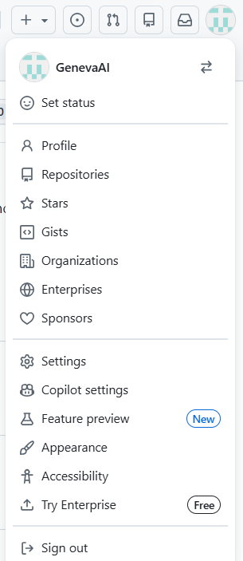
4. In the left sidebar scroll down to Developer settings
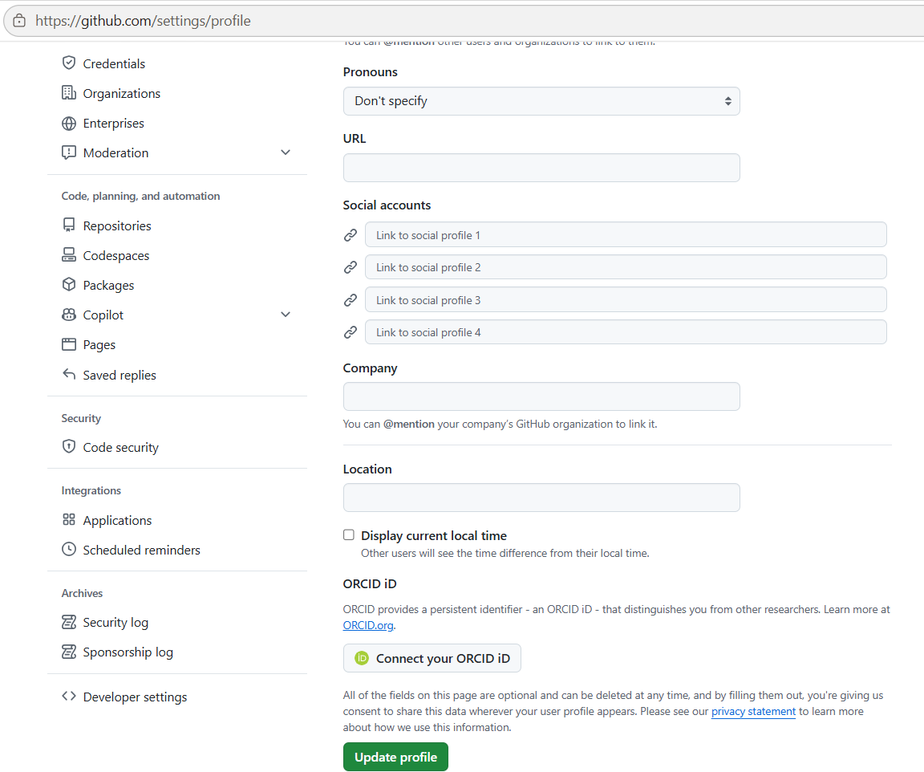
- Click Personal access tokens → Tokens (classic)
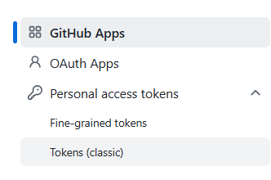
6. Click Generate new token → Generate new token (classic)
- Give it a name (e.g. “My laptop”), set an expiration (90 days is fine), and check the box repo
- Click Generate token at the bottom
- Copy the token immediately (you will not see it again). It starts with ghp_...
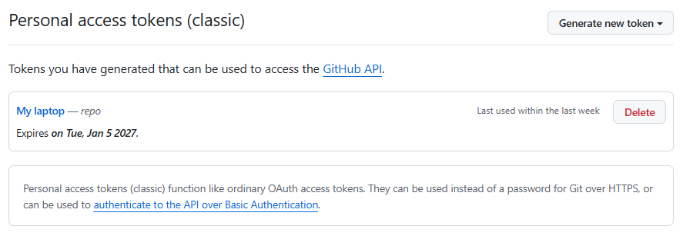

Make sure GitHub’s Push Protection does not block your code push
Make sure that GitHub’s Push Production does not block your code push because it detects secrets in your API’s .env file.

Make sure .env is ignored as follows:
1. Open a CMD (Terminal) Window

2. Move to your prod_api folder:
cd <path to>\prod_api

(Replace <path to> with the real location of prod_api on your computer)

3. Run:
echo .env >> .gitignore
git add .gitignore
git commit -m "Add .env to .gitignore"

Push the Code
1. Open a CMD (Terminal) Window

2. Run:
git push -u origin main

3. GitHub will ask you to log in:
  - Username: your GitHub username
  - Password: you must use the Personal Access Token you created in the previous section, not your normal GitHub password

4. You should now see the successful push of your code to your GitHub repository, for example:
Enumerating objects: 5312, done.
Counting objects: 100% (5312/5312), done.
Delta compression using up to 12 threads
Compressing objects: 100% (4720/4720), done.
Writing objects: 100% (5312/5312), 49.87 MiB | 2.25 MiB/s, done.
Total 5312 (delta 467), reused 5312 (delta 467), pack-reused 0 (from 0)
remote: Resolving deltas: 100% (467/467), done.
To https://github.com/<YOUR USER NAME>/prod_api.git
* [new branch] main -> main

Quick checklist after the push
1. Open your repository in Git GUI
2. On the top menu, select Repository / Browse main’s files
3. You should now see a dialog box with your code in GitHub
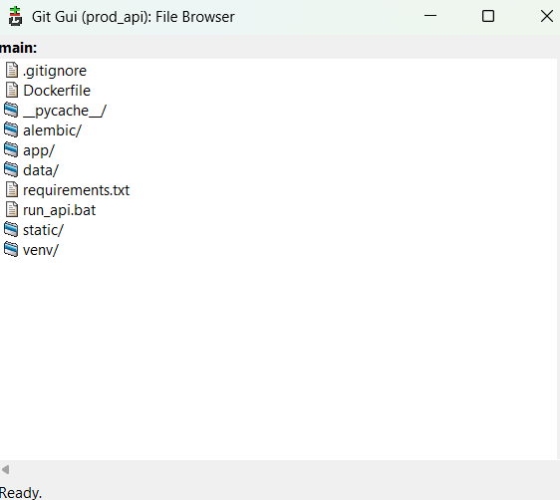

TIP: You continue to maintain your code locally in the sub folders of your prod-api folder on your PC
- The locally made changes will appear in Git GUI as “Unstaged Changes”
- After you have locally tested your code changes to ensure they do not cause unexpected errors, you can commit and push your changes in Git GUI
Goal | How to do it in Git Gui
See if there are any changes | Click the Rescan button (bottom-left).
Make changes | Edit files in your code editor (VS Code, etc.), save them, then come back and click Rescan. The changed files will appear under Unstaged Changes.
Stage files for commit | Select files in the Unstaged list → click Stage Changed (or right-click → Stage).
Commit | Type a message in the Commit Message box → click Commit.
Push to GitHub | After committing, click Push  .
View commit history | Menu → Repository → Visualize All Branch History (or just Visualize).
Switch / create branches | Menu → Branch.
Fetch / Pull from remote | Menu → Remote → Fetch from / Pull.

Note also that your Docker container does not need to be changed again locally, even after you make changes to the code locally on your PC and commit the changes to GitHub:
- Render builds a new Docker image automatically when you push code to GitHub (because the service is configured to use your Dockerfile)

Create and deploy the API’s Web Service on Render

Step-by-step deployment
- Go to Render
Open https://render.com and log in with the Render account you created (see the Readme.txt section earlier in this document)

- Create a new Web Service
  - Click the + New button (top right)
  - Choose Web Service

- Connect your GitHub repository
  - Click Connect GitHub (or GitLab/Bitbucket) and authorize Render
  - Select the repository YOUR-USERNAME//prod_api (or search for it)
  - Click Connect

- Configure the new web service (important settings)
Setting | What to choose / enter | Notes
Name | Any name you like which is available | Becomes part of the URL  In the rest of the document, this Name will be referred to as YOUR-API-NAME
Region | Closest to your users (e.g. Frankfurt) | --
Branch | Main | Auto-selected
Root Directory | Leave blank | Dockerfile is in the root
Runtime / Language | Docker | IMPORTANT: Do not choose Python
Dockerfile Path | ./Dockerfile (or just leave default) | Only change if it’s in a subfolder
Docker Command | Leave empty | Render will use the CMD from your Dockerfile
Instance Type | Free | Good for testing  - Spins down after inactivity, and requires up to a minute to start up after a user goes to the URL of your API in a Web browser

- Environment Variables (optional but recommended)
Scroll to Environment and add any secrets your app needs:
  - Make sure that ALL variables in your .env file are added in your Render web service with exactly the same values (for more details, see section .env earlier in this document)
  - Render injects these environment variables both at build time and runtime

Note: your DATABASE_URL will initially be your local SQLite database which was transported to GitHub as part of your Docker container. After you thoroughly test the Render web service, you can switch your API’s database to a new PostgreSQL database created on Render.

- Create the service
Click Create Web Service.

Render will then do the following automatically:
- Clone your repository.
- Build a Docker image using your Dockerfile (and requirements.txt).
- Start the container with the command from your Dockerfile:
uvicorn app.main:app --host 0.0.0.0 --port 8000

You can watch the build logs in real time on the service’s Events / Logs page
- You can also use the logs to help you debug any issues that occur during the deployment process
Once the deploy finishes, you’ll get a public URL like:
https:// YOUR-API-NAME -xxxx.onrender.com

FRONTEND_URL
- Change the value of the environment variable FRONTEND_URL to the public URL of your new Render web service, which you got after you deployed the service for the first time

Deployment Notes:

Topic | Notes
Automatic deploys | By default, every push to the main branch on GitHub will automatically trigger a new build and deploy on Render. This is convenient during the testing phase.  If you wish, you can turn this off later in Settings → Auto-Deploy.
Free tier note | The free instance sleeps after about15 minutes of inactivity and takes up to a minute to wake up on the next request.
Health checks | Render automatically hits your root path. If you prefer, set a health-check path (e.g. /health) under Advanced.
Custom domain | After the first successful deploy and test, if needed you can add your own domain in the service settings.
Force a redeploy | In the Render dashboard → your service → Manual Deploy → Deploy latest commit.

Thoroughly test your Render API with the SQLite database
Test all pages of your Render API listed in previous section: Fully test your API locally
- Main difference:
Use <your Render API’s Public URL> as the URL before your API pages (instead of your local http://127.0.0.1:8000/)

Create and deploy a PostgreSQL database for production

Create a Render Postgres database
1. Go to Render:
Open https://render.com and log in with the Render account you created (see the Readme.txt section earlier in this document)
2. Go to the Render Dashboard: https://dashboard.render.com
2. Click + New → Postgres
(or go directly to https://dashboard.render.com/new/database)
3. Fill in the form:
Attribute | Notes
Name | Something descriptive (e.g. ‘my-app-db’)  You can change this later
Database and User (optional) | Leave blank and Render will generate them  These cannot be changed after creation
Region | Choose the same region as your web service.  This is important for low latency and private network access
PostgreSQL Version | Use the latest available
Instance type / Plan | Free is available for testing (with limitations). Paid plans give more resources, backups  IMPORTANT: Free databases expire after 30 days and are intended for testing and prototyping

4. Click Create Database
Wait a minute or two until the status shows Available.

Get the connection string (‘DATABASE_URL’)
1. Open your new database in the dashboard
2. Click the Connect button (top right) or go to the Info / Connect tab
3. You’ll see two URLs:
- Internal Database URL → Use this for your Render web service (same region). Preferred — faster and stays on Render’s private network
- External Database URL → Use this only for local development, tools outside Render, or services in a different region. It requires SSL

Copy the Internal Database URL
- The Internal Database URL will have the following format: postgresql://<string>
- Modify the value to postgresql+psycopg2://<string>

Note/save the Modified Internal Database URL somewhere.

Add the connection string to your web service
1. Go to your web service in the Render Dashboard.
2. Click Environment in the left sidebar.
3. Click Edit
4. Change the value of the DATABASE_URL Key:
- Key: DATABASE_URL
- Value: Paste the Modified Internal Database URL you noted earlier.
5. Click the Save, rebuild, and deploy button at the bottom right.

Quick tips
- Always prefer the Internal URL when both the app and database are on Render.
- Free databases have limitations (sleep after inactivity, storage limits, expiry after 30 days, etc.). Upgrade when you need reliability.
- Never commit the connection string to Git. Keep it only in Render’s Environment Variables.
- For local development, use the External URL in your local .env file (or a local Postgres instance)

Create your first admin user manually

Install PostgreSQL client (psql)
For Windows
- Download the official installer: https://www.postgresql.org/download/windows/
- During installation you can uncheck everything except “Command Line Tools”, unless you are interested in also installing a local PostgreSQL database on your PC (like I did).
- Make sure the bin folder (usually C:\Program Files\PostgreSQL\16\bin) is added to your PATH.

Using psql, check that the users table has been created properly in your new PostgreSQL database
1. Open a CMD (Terminal) Window
2. Run:
psql <THE EXTERNAL_DATABASE_URL OF YOUR POSTGRESQL DATABASE>
(If you get an SSL error, force it: psql <THE EXTERNAL_DATABASE_URL OF YOUR POSTGRESQL DATABASE>?sslmode=require)

You will now see the psql prompt
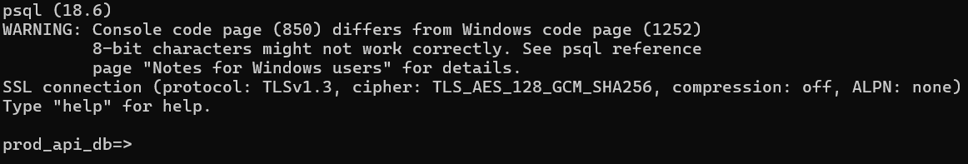

For the purposes of the documentation below, we will assume that your PostgreSQL database is called prod_api_db, although the name you will see is the name you gave your PostgreSQL database when you created it.

3. Run: \d users
If the users table was properly created in your PostgreSQL database, you should now see the columns of an empty user’s table:
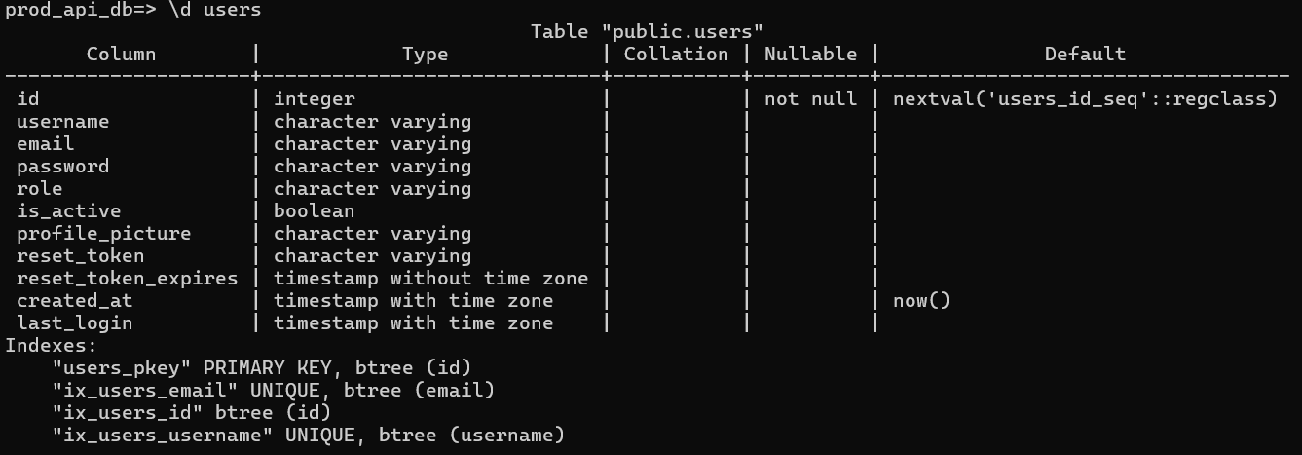

4. Run: SELECT * from users;
You should see that the users table has no records added yet:

Generate a correct password hash for your first admin user
1. In your local prod_api folder on your PC, create a new Python file: HashForFirstUserInPostgreSQL.py for one-time use with the following code:
from passlib.context import CryptContext
pwd_context = CryptContext(schemes=["argon2"], deprecated="auto")
print(pwd_context.hash(“<cleartext strong password for your first admin user>"))

- In a CMD (terminal) window, go to the prod_api folder and activate your Python virtual environment as described in the section Readme.txt

- Run HashForFirstUserInPostgreSQL.py
Python HashForFirstUserInPostgreSQL.py

- Note down somewhere the password hash which is printed by your program

- It is best practice to remove the cleartext password from the code in HashForFirstUserInPostgreSQL.py immediately afterwards

Insert your first admin user
1. Go back to your CMD (terminal) Window with the psql prompt

2. Add your first admin user to the users table of your PostgreSQL database using an INSERT command in psql:
INSERT INTO users (
username,
email,
password,
role,
is_active,
profile_picture,
reset_token,
reset_token_expires,
created_at,
last_login
)
VALUES (
'a-<user name>',
‘<email address>’,
‘password hash‘,
'admin',
true,
NULL, -- profile_picture
NULL, -- reset_token
NULL, -- reset_token_expires
CURRENT_TIMESTAMP, -- created_at
NULL -- last_login
);

4. Confirm that your first admin user has been added to the users table Run:
SELECT * from users

This time you should see 1 record in the users table (your newly created admin user)

Create additional users
1. Open a web browser, go to <your Render API’s Public URL>/login-page
- Then login with your newly created admin user

2. After being authenticated, open another tab on the web browser and go to <your Render API’s Public URL>/docs
- Using , create one or more new standard users

Thoroughly test your Render API with your new PostgreSQL database
Test all pages of your Render API listed in previous section: Fully test your API locally
- Main difference:
Use <your Render API’s Public URL> as the URL before your API pages (instead of your local http://127.0.0.1:8000/)

Docker can also be installed on macOS, or Linux with virtualization enabled
Git can also be installed on MacOS or Linux
Git can also be installed on MacOS or Ubuntu / Debian
The standard Argon2id encoded hash contains: Algorithm (argon2id), Version, Parameters, Salt (base64), Hash/digest (base64)

